Article -

<https://www.thestar.com.my/aseanplus/aseanplus-news/2022/10/25/thailand-has-highest-income-inequality-in-east-asia-world-bank-rural-poverty-report-finds>

Word Count – 798 words

Thailand has the highest income inequality in east Asia, with rural households bearing the brunt of poverty challenges, according to a new report by the World Bank.

The report, titled “Thailand Rural Income Diagnostic”, said the national poverty rate has fallen from 58% in 1990 to 6.8% – but has been rising since 2016.

The situation is especially bad in rural areas, which account for 79% of the poor, mainly in agricultural households.

The poverty rate in rural areas was 3% higher than in urban zones in 2020.

The bank cited the slowing economy, stagnating farm and business incomes, and the Covid-19 crisis as reasons for Thailand’s rising poverty rate.

Worst affected by poverty are the South and Northeast, with rates almost double those of the national average, according to the report.

Meanwhile, the average monthly income for rural households was only around 68% of urban households. The report said rural households are also suffering from low education levels, a high number of dependents, and difficult living conditions.

“Thailand has the potential to support faster and sustained income growth of rural households,” said Fabrizio Zarcone, World Bank country manager for Thailand.

“As Thailand’s economy adjusts to a new normal post-Covid-19, policy measures that increase agricultural productivity, support diversification to higher value crops, and improve access to markets through better rural connectivity and digital technology adoption can help overcome the constraints faced by the rural poor,” he added.

The report also forecast that the economic impacts of the Covid-19 crisis would linger longer in rural areas than in cities.

This article discusses growing poverty and inequality in Thailand, especially in rural areas. Income inequality refers to the degree that people in a population differ in the amount of income they earn. Income inequality closely relates to the key concept, **equity**. **Equity** refers to the idea of being fair or just and is based on the idea that everyone must have equal opportunity to succeed.

As the article mentions, the poverty rate in Thailand has been increasing since 2016. It mentions how poverty is concentrated in rural areas rather than urban areas. This corresponds to a growing income inequality (as people in urban areas earn a larger proportion of income than those in rural areas) which can be illustrated using a Lorenz curve.

**Figure 1 - Lorenz Curve Of Thailand Since 2016**

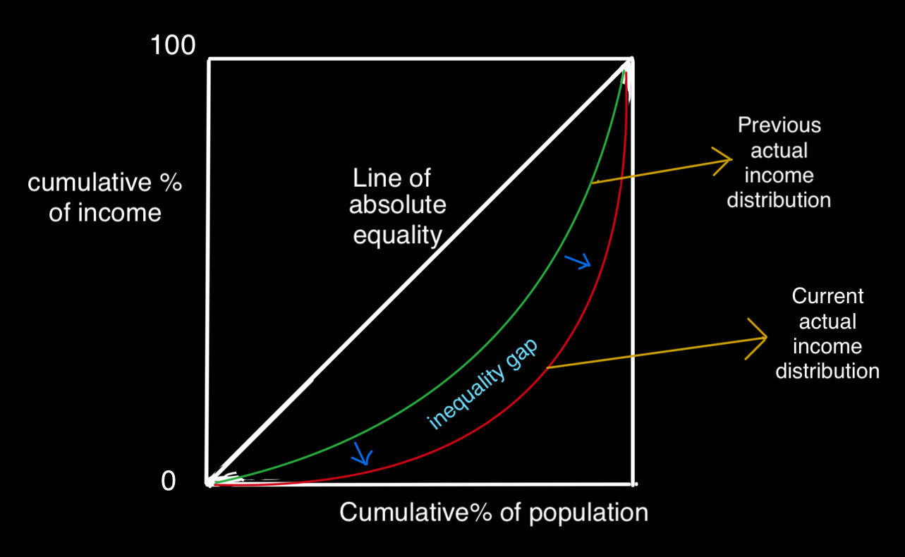

In **Figure 1**, the Lorenz curve of Thailand shifts further away from the Line of absolute equality. This means that the lower quintiles of the population are now earning a smaller percentage of the national income, while the upper quintiles of the population earn a higher percentage of the national income as implied by the quote, “poverty rate…rising…2016”

Though inequality and **inequity** of income represent two different concepts, they have similar meanings. As the article mentions, rural areas have access to lower income. This leads to economic **inequity** because those in rural areas have a lesser ability to invest in education and health care, hence depriving their opportunities. Having better education allows people to stop working in low-pay, low-skilled jobs, and work in high-pay, high-skilled jobs. Better access to health care allows individuals to live longer and stay more efficient. **Inequity** could lead to social mobility, which harms social and political stability. This makes society unfair because those with better economic status have access to better education and healthcare, hence better opportunities.

To correct the problem of **inequity**, the text mentions that there should be a policy implemented to "increase agricultural productivity… better rural connectivity". This policy involves investment in public services and particularly in the agricultural sector. In addition, it means the government should make investments in infrastructure to strengthen rural connectivity.

If the government invests in public services such as agriculture, healthcare, and education this could greatly reduce inequality of opportunity, which promotes **equity**. Additionally, this could also increase long-term economic growth as it improves the quality of human capital. This increases labour productivity and efficiency in production, causing LRAS (Long-run Aggregate Supply) to shift to the right. This corresponds to a growth in Real GDP.

**Figure 2 - Growth In Real GDP Due To Policies**

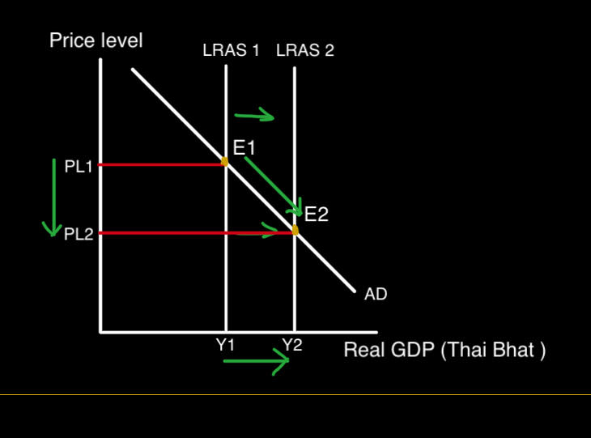

Initially, the Thailand economy has a potential output of Y1 as indicated by the intersection of AD (Aggregate Demand) and LRAS1 at PL1 and Y1. Due to improvements in human capital which further leads to improvements in efficiency, LRAS1 shifts to LRAS2 and intersects AD at the new potential output Y2 at a lower price level PL2. Investment in human capital could help correct "low education levels … difficult living conditions" as it could improve the quality of labour in rural areas, hence increasing employment and income in those areas.

There are several advantages associated with investments in human capital. Government spending in human capital in the long-term can greatly reduce inequality of opportunity and promote both economic growth and **equity**. Additionally, government spending can be catered to focus on a specific sector that can most increase efficiency and employment. In the case of Thailand, this is agriculture. Investments in human capital also considerably improves the productivity of workers, and investments in infrastructure, which is a form of physical capital, could drastically reduce transportation costs hence further encourage the long-term economic growth of the country.

Though policies to promote **equity** benefit the economy, there are several disadvantages associated with them. High government spending in human capital could lead to a budget deficit. This could jeopardise the ability of the economy to grow in the future as it would have high debt to pay in the future. Government spending also has opportunity cost in the form of losing income to invest in other policies such as transfer payments or minimum wages. Additionally, high government spending also has the effect of increasing AD, which could lead to high inflation in the economy if pursued for too long. Lastly it could also lead to crowding out as the government could deprive the finite quantity of savings, reducing private sector borrowing and hence investment.

An alternate policy that could be pursued is a progressive tax system. This increases the percentage of income paid as tax in higher income individuals, hence correcting income inequality. Additionally, the increased government revenue could then be used to pursue high government spending without leading to a budget deficit. Though this policy corrects the problem of budget deficit and income inequality, it does not correct the problem of high inflation in the economy due to government spending.